**ASSIGNMENT-1**

**QUESTION 1 -- WAP to check whether a given is Armstrong or not ?**

**SOLUTION-**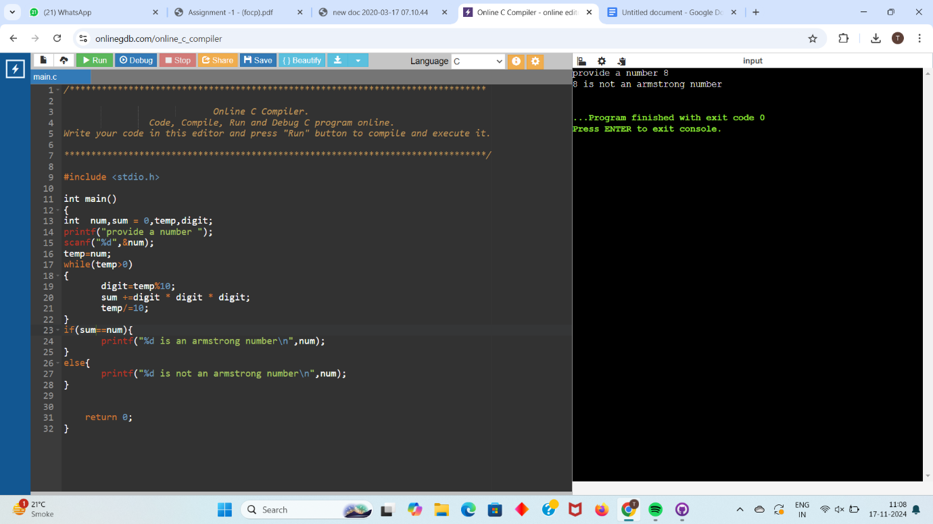

**QUESTION 2--- WAP to read two integers and print their HCF ?**

**SOLUTION-**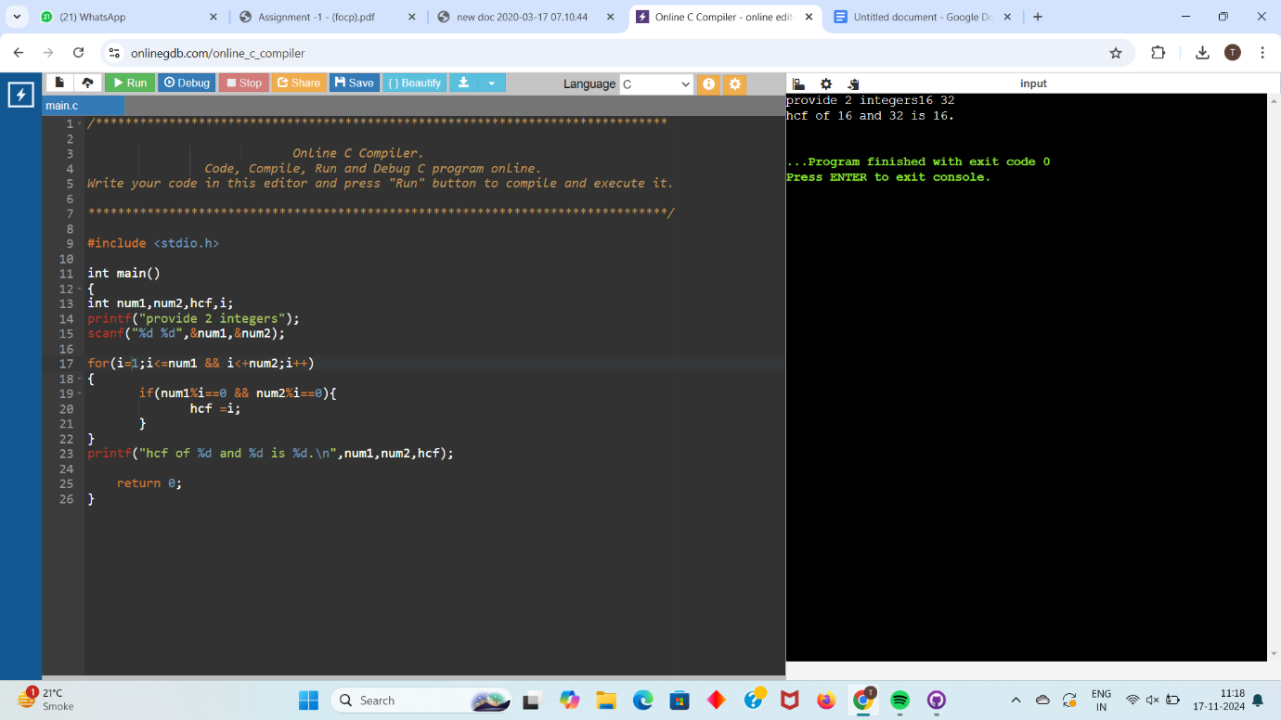

**QUESTION 3--WAP to subtract two integers without using Minus(-) operator.(hint Bitwise operator)?**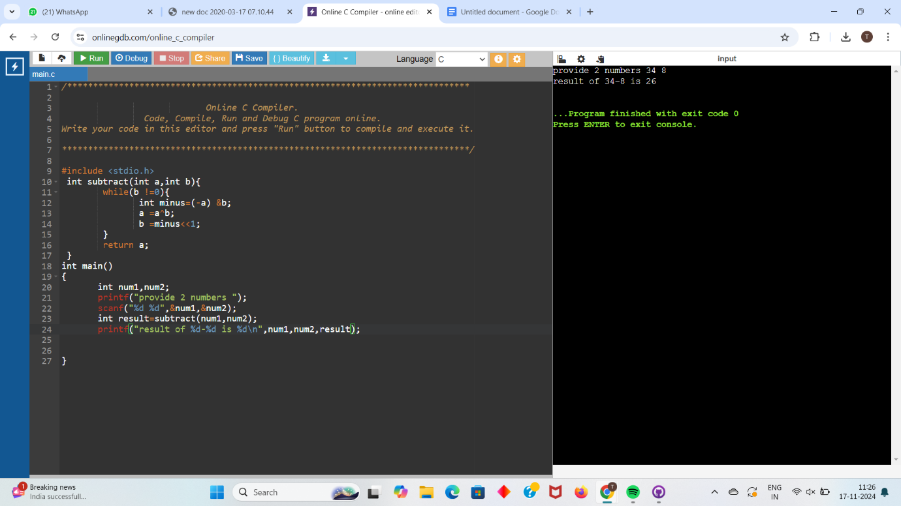

**QUESTION 4--Wap to accept 2 integers numbers and swap them using 4 different methods in C language ?**

**Method 1-**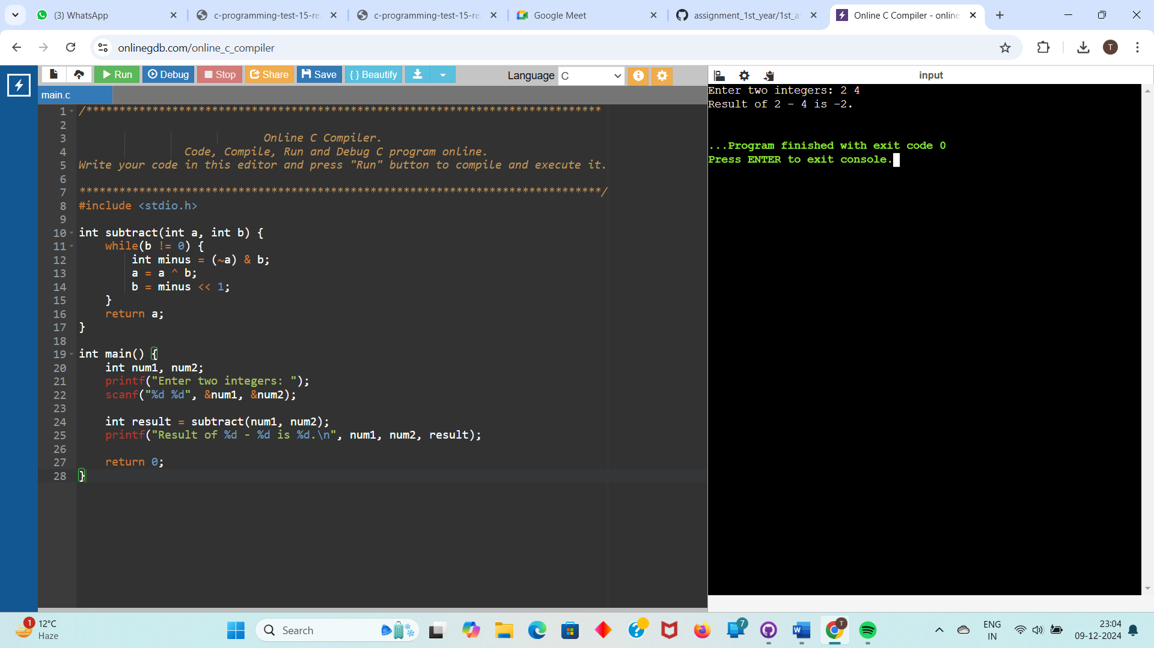

**Method 2-**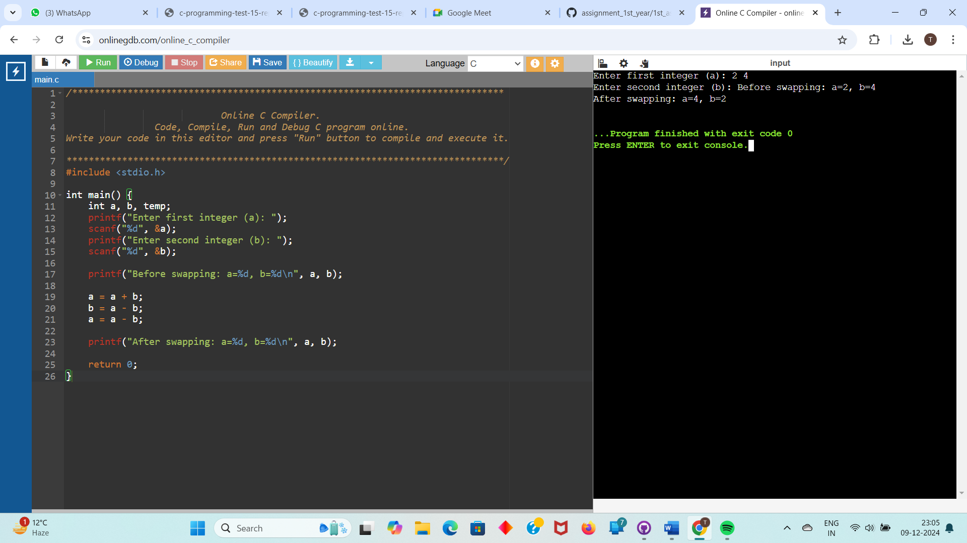

**Method 3-**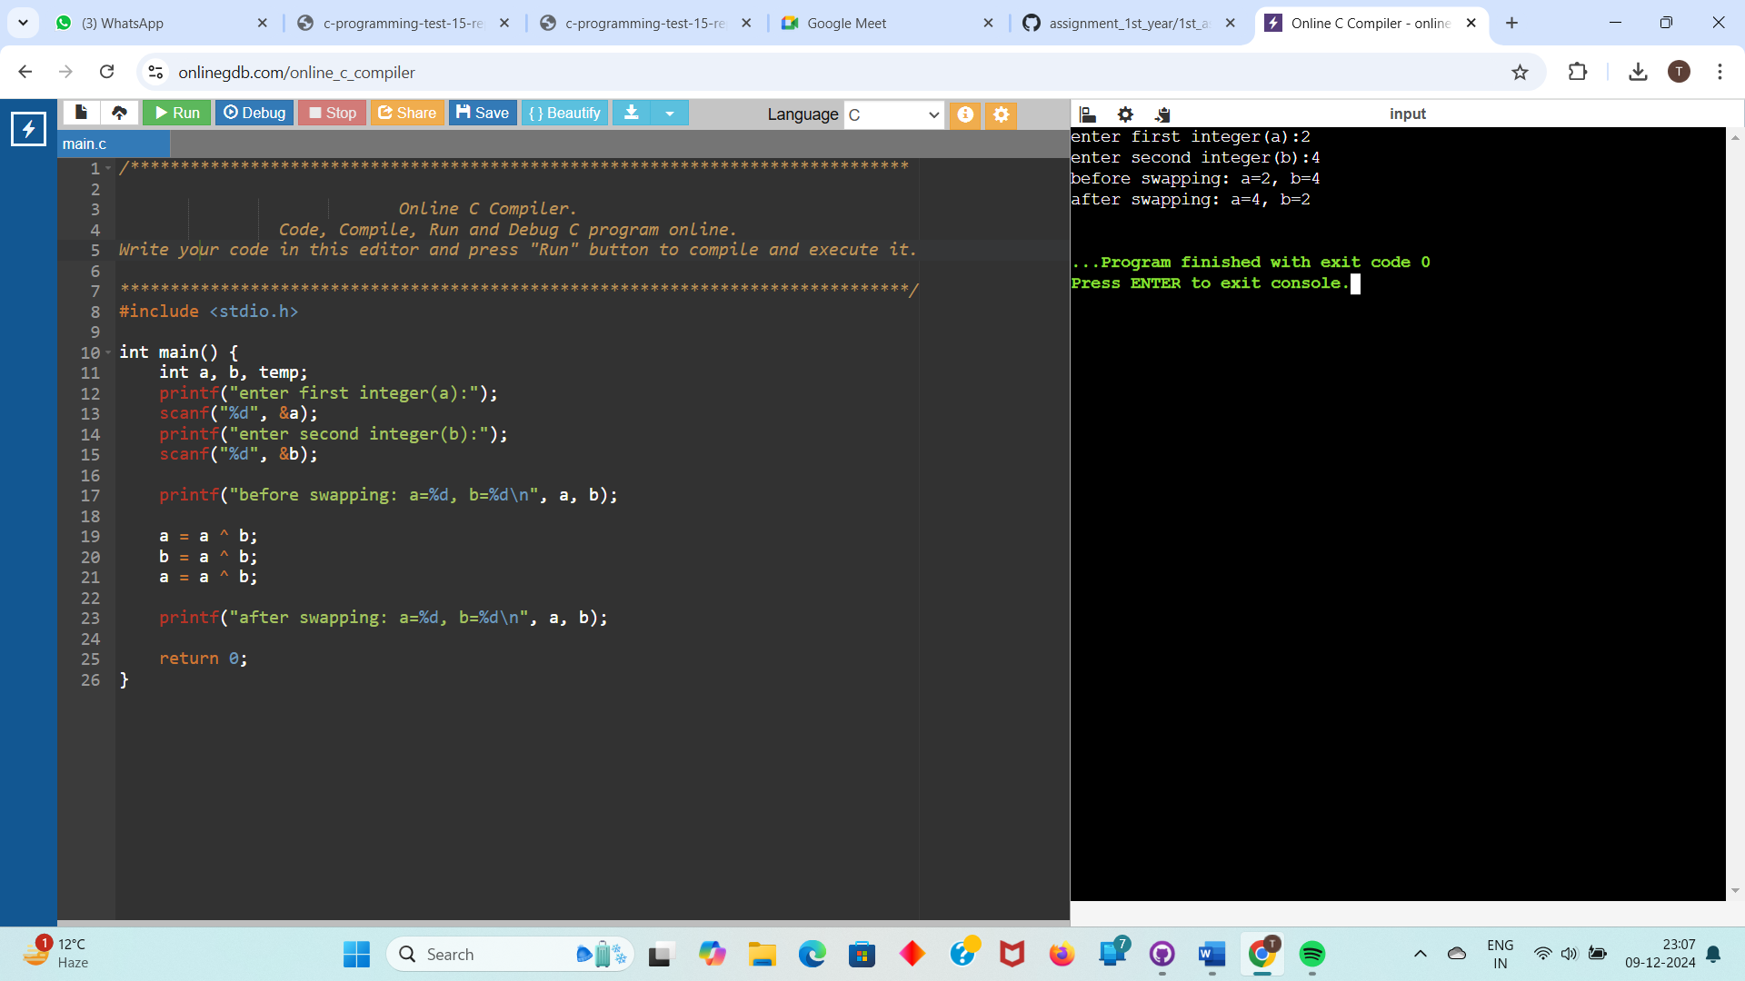

**Method 4-**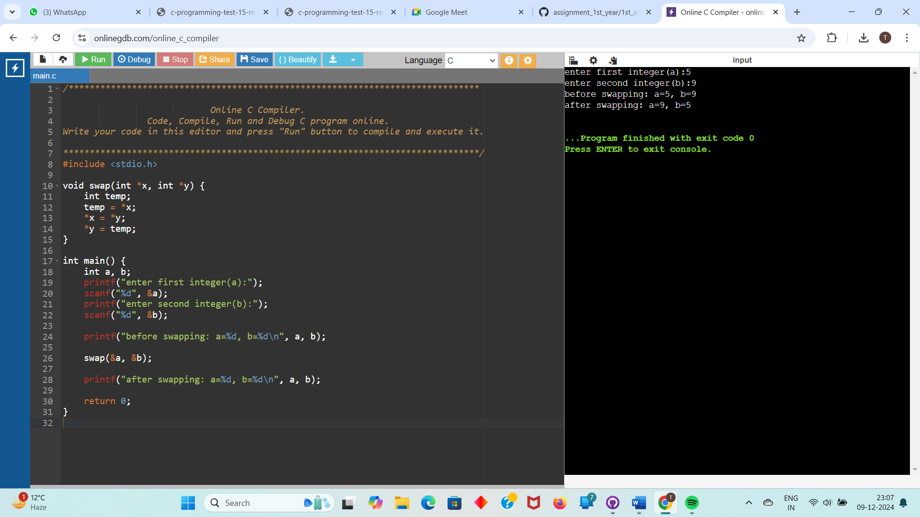

**Question 5-WAP to check whether number is Perfect Number or not. (To check perfect**

**number, we have to find all divisors of that number and find their sum, if sum of divisors is**

**equal to number it means number is Perfect Number.)**

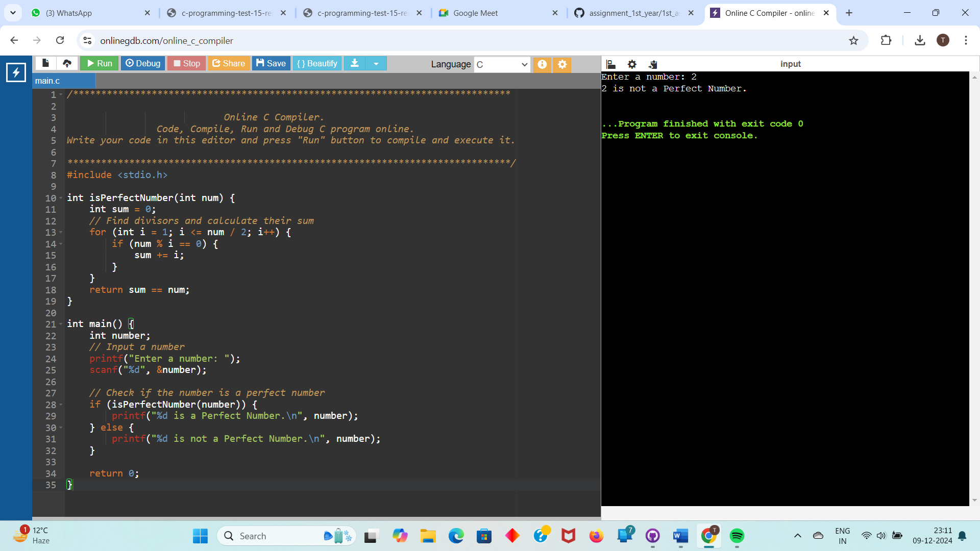

**Question 6- WAP to accept a coordinate point in an XY coordinate system and determine in**

**which quadrant the coordinate point lies.**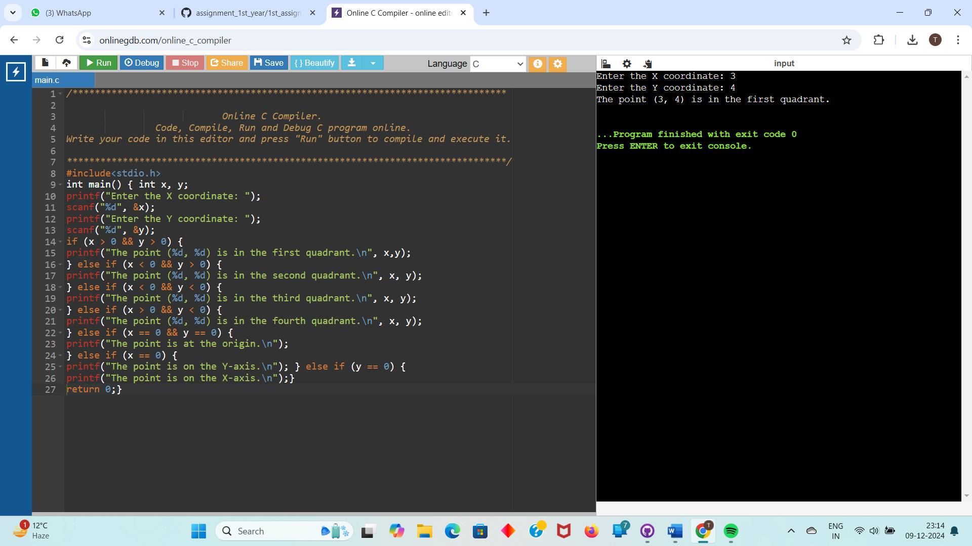

**Questions 7- WAP to print below mentioned pattern:**

**# 1**

**# 01**

**# 101**

**# 0101**

**# 10101**